An Ultra-Low-Power 10-Transistor 1-Bit Magnitude Comparator Using Gate Diffusion Input Technique
Shahrear Hossain Shawon^{a,∗}, Riazul Islamª
aDepartment of Electrical and Electronic Engineering, International Islamic University Chittagong, Bangladesh

Abstract
Digital magnitude comparators serve as indispensable arithmetic building blocks in modern Very Large Scale Integration (VLSI) systems, including arithmetic logic units, flash analog-to-digital converters, and data sorting engines. Conventional static Comple-mentary Metal-Oxide-Semiconductor (CMOS) implementations of 1-bit comparators typically require 32 transistors, resulting in elevated power dissipation and silicon area overhead. This paper presents the design, transistor-level implementation, and com-prehensive performance evaluation of an ultra-low-power 1-bit magnitude comparator based on the Gate Diffusion Input (GDI) technique. The proposed architecture generates all three comparison outputs (A > B, A = B, and A < B) using only 10 transistors, achieving a 68.75% reduction in device count over the standard static CMOS topology. The circuit was modeled and simulated using LTSpice with the 180 nm Berkeley Predictive Technology Model at a supply voltage of 1.8 V. Simulation results demonstrate
an average power dissipation of 34.18 pW, a propagation delay of 336 ps for the equality output, and a Power-Delay Product (PDP) of 1.14 × 10⁻⁵ fJ. Compared with the conventional static CMOS design, the proposed GDI comparator achieves a 73.83% reduction in power consumption, a 15.59% improvement in switching speed, and a 77.65% improvement in energy efficiency. Benchmark-ing against four published comparator architectures confirms that the proposed design attains the lowest PDP among all evaluated topologies. Multi-node scaling evaluations across 180 nm, 90 nm, and 45 nm technology regimes further validate consistent per-
formance scalability. The proposed GDI comparator is well-suited for deployment in battery-operated, energy-harvesting, and biomedical VLSI applications.
Keywords: Gate Diffusion Input (GDI), magnitude comparator, low-power VLSI, CMOS logic design, Power-Delay Product, Predictive Technology Model

Introduction
The relentless scaling of semiconductor technology over the past several decades has enabled the integration of billions of transistors onto a single silicon die, powering a diverse range of computing platforms from high-performance server processors to ultra-compact wearable health monitors [14]. As transistor gate lengths shrink below the 100 nm threshold, the interplay between dynamic switching power and static leakage current has fundamentally altered the power dissipation landscape of digital integrated circuits [15, 12]. In battery-operated portable electronics, wireless sensor nodes, and implantable biomedical devices, power consumption has emerged as the single most critical design constraint, often surpassing speed and area in overall importance.
Among the foundational arithmetic building blocks of dig-ital computing architectures, digital magnitude comparators occupy a particularly important position. These circuits ac-cept two binary operands and generate outputs that indicate whether one operand is greater than, equal to, or less than the other. Comparator circuits find extensive deployment in

∗Corresponding author.
Email addresses: sshahrearhossain@gmail.com (Shahrear Hossain Shawon), iriazul74@gmail.com (Riazul Islam)
arithmetic logic units (ALUs), central processing units (CPUs), digital signal processors (DSPs), data sorting networks, prior-ity encoders, and high-speed flash analog-to-digital converters (ADCs) [7, 13]. The performance characteristics of comparator modules—namely propagation delay, power dissipation, and silicon area—directly influence the throughput, energy budget, and physical footprint of the larger digital systems in which they are embedded.
The conventional approach to implementing a 1-bit magni-tude comparator employs static CMOS logic, which provides robust noise margins, full rail-to-rail output voltage swing, and predictable switching behavior. However, a standard static CMOS realization of a complete 1-bit comparator typically de-mands 32 transistors, resulting in substantial parasitic capaci-tance, elevated dynamic and leakage power consumption, and a relatively large silicon die area [9]. Several alternative logic families have been explored to reduce these overheads, includ-ing Pass Transistor Logic (PTL) and Transmission Gate Logic (TGL). While PTL can reduce transistor count, it suffers from threshold voltage drops that degrade output voltage levels and noise margins. TGL provides full-swing outputs through com-plementary NMOS–PMOS switch pairs but requires additional inverters, increasing the overall device count [14].
The Gate Diffusion Input (GDI) technique, introduced by

Morgenshtein et al. [16], offers an elegant circuit design paradigm that permits the realization of complex Boolean logic functions using a significantly reduced number of transistors compared to conventional CMOS and pass-transistor imple-mentations. A basic GDI cell comprises only two transistors—one PMOS and one NMOS—sharing a common gate terminal and a common drain (output) terminal. Unlike standard CMOS inverter topologies, where the PMOS source is tied to V_{DD} and the NMOS source is tied to ground, the GDI cell routes arbitrary input signals to the diffusion (source) terminals, enabling the synthesis of diverse logic functions such as AND, OR, MUX, and XOR with minimal device overhead [16, 5].
Recent investigations into comparator circuit design have ex-plored various strategies for improving power and delay perfor-mance. Sharma et al. [1] presented a hybrid PTL–GDI–TGL comparator with an impressively low 5.5 ps delay, but the de-sign requires 24 transistors and consumes 7.3 µW of average power. Lubaba et al. [2] designed a 2-bit hybrid compara-tor using Pass Transistor, Transmission Gate, and conventional CMOS logic in 90 nm technology, achieving 192 ps delay but with microwatt-level power dissipation (7.792 µW). Tailor et al. [3] employed Multi-Threshold CMOS (MTCMOS) with forced stack techniques, reporting a delay of 330.61 ps and power consumption of 48.12 pW; however, the dual-threshold fabrication process introduces additional manufacturing com-plexity and cost. Kumar and Kumar [4] applied transistor stacking techniques to a static CMOS comparator in 180 nm technology, achieving reduced leakage power but with a 45+ transistor count and a propagation delay of 49.38 ns. These existing works highlight a persistent trade-off: designs that achieve aggressive delay targets tend to exhibit high active power consumption, while ultra-low-power topologies often sacrifice switching speed or require specialized fabrication pro-cesses.
This paper addresses these limitations by presenting a pure
GDI-based 1-bit magnitude comparator that achieves picowatt-level power consumption with sub-nanosecond switching delay using only 10 transistors. The principal contributions of this work are as follows:
- A complete 10-transistor GDI-based 1-bit magnitude com-parator generating all three comparison outputs (A > B, A = B, A < B) with minimal device count and no require-ment for specialized fabrication processes.
- A systematic four-way performance benchmarking against static CMOS (32T), Pass Transistor Logic (10T), and Transmission Gate Logic (16T) comparators under iden-tical 180 nm PTM simulation conditions.
- A comprehensive comparative analysis against four published comparator architectures from the literature, demonstrating that the proposed design achieves the low-est Power-Delay Product among all evaluated topologies.
- A multi-node technology scaling evaluation across 180 nm, 90 nm, and 45 nm Predictive Technology Model
DD

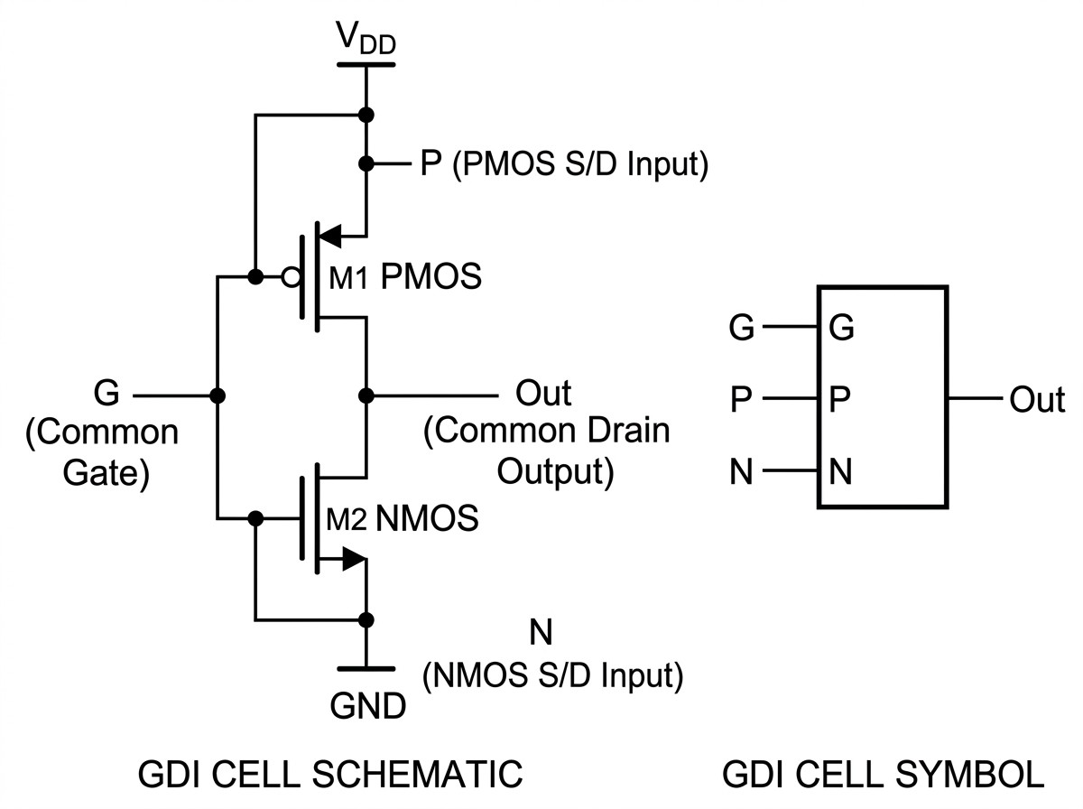
Figure 1: Basic GDI cell: transistor-level schematic (left) and symbolic repre-sentation (right). The cell comprises one PMOS (M1) and one NMOS (M2) with a common gate (G) and common drain output. The PMOS source (P) and NMOS source (N) accept independent input signals.

functions. Section 3 describes the proposed comparator archi-tecture and its Boolean-to-GDI mapping. Section 4 details the simulation methodology and testbench configuration. Section 5 presents the simulation results and performance comparisons. Section 6 provides detailed analysis and discussion. Section 7 draws conclusions and outlines directions for future research.

Gate Diffusion Input technique: cell structure and logic functions
The Gate Diffusion Input methodology was first proposed by Morgenshtein, Fish, and Wagner as an alternative to conven-tional CMOS logic for low-power digital circuit design [16]. The fundamental GDI cell, depicted in Fig. 1, consists of two complementary transistors arranged in a topology that closely resembles a standard CMOS inverter. The PMOS transistor (M1) and the NMOS transistor (M2) share a common gate ter-minal, designated as input G, and a common drain connection that forms the cell output. The distinguishing characteristic of the GDI structure lies in its diffusion terminal assignments: the source of the PMOS transistor is driven by an independent in-put signal P, while the source of the NMOS transistor receives a separate input signal N. This three-input configuration (G, P, N) enables a single GDI cell to implement multiple logic func-tions by simply altering the signal assignments at its terminals, as summarized in Table 1.
The GDI technique offers several inherent advantages over conventional CMOS logic for low-power applications. First, since a single GDI cell can realize functions that would other-wise require four to twelve transistors in standard CMOS, the overall transistor count is substantially reduced. This reduc-tion directly lowers parasitic gate, drain, and interconnect ca-pacitances, which in turn decreases dynamic switching power

decks, confirming sustained performance scalability.
(Pdyn ∝ CloadV2
f ) and silicon die area. Second, fewer internal

The remainder of this paper is organized as follows. Sec-tion 2 reviews the GDI cell structure and its fundamental logic
switching nodes translate into reduced short-circuit current dur-ing logic transitions, further lowering active power consump-tion. Third, the GDI cell provides direct signal routing through

Table 1: Logic functions realizable with a single GDI cell.
Function | Output Expression | N | P | Description
F1 | G¯ · P | 0 | B | AND with inverted gate
F2 | G + P | B | 1 | OR function
INV | G¯ | 0 | 1 | Standard inverter
MUX | G¯ P + GN | B | C | 2-to-1 multiplexer
XOR | G¯ B + GB¯ | B¯ | B | Exclusive-OR
XNOR | G¯ B¯ + GB | B | B¯ | Exclusive-NOR

Table 2: Truth table for a 1-bit magnitude comparator.
Input A | Input B | A > B | A = B | A < B
0 | 0 | 0 | 1 | 0
0 | 1 | 0 | 0 | 1
1 | 0 | 1 | 0 | 0
1 | 1 | 0 | 1 | 0

transistor diffusion terminals, eliminating the need for separate buffering stages and reducing propagation delay through criti-cal signal paths [16, 5].
A practical consideration for GDI circuits in bulk CMOS processes is the body effect. In standard bulk CMOS fabrica-tion, NMOS body terminals are connected to ground and PMOS body terminals are tied to V_{DD}. When GDI input signals drive the source terminals to potentials other than these fixed refer-ences, the resulting source-body voltage (V_{S} _{B} ≠ 0) can shift the effective threshold voltage and slightly affect output volt-age swing under certain load conditions. Nevertheless, for the logic functions employed in this work, simulations confirm that the output voltage degradation remains within acceptable noise margin bounds at the 180 nm technology node with a 1.8 V sup-ply.

Proposed GDI-based 1-bit magnitude comparator

  - Truth table and Boolean derivation
A 1-bit magnitude comparator accepts two single-bit binary inputs, A and B, and produces three mutually exclusive output signals: A > B (greater-than), A = B (equality), and A < B (less-than). The truth table governing the operation of the com-parator is presented in Table 2.
Applying Karnaugh-map minimization to the truth table en-tries yields the following simplified Boolean expressions for each output:

(A > B) = A · B (1)
(A = B) = A ⊙ B = A ⊕ B = AB + A B (2) (A < B) = A · B (3)
Table 3: GDI cell terminal assignments for each comparator output.
Output | Boolean Function | G | P | N | Transistors
A > B | A · B | B | A | GND | 2
A < B | A · B | A | B | GND | 2
A = B | A ⊙ B (XNOR) | A | B | B | 2
Inverter A | A | A | VDD | GND | 2
Inverter B | B | B | VDD | GND | 2
Total transistor count: |  |  |  |  | 10

These expressions reveal that the greater-than and less-than outputs are simple two-variable AND operations with one in-verted input, while the equality output is an XNOR (equiva-lence) function. Each of these operations maps directly to a basic GDI cell configuration.
  - Mapping Boolean functions to GDI cells
The proposed design maps each comparator output to a ded-icated 2-transistor GDI cell, as detailed below and summarized in Table 3.

Greater-than output (A > B = A · B): This function is im-plemented using a GDI cell configured as the F1 function. The
gate terminal (G) is connected to input B, the PMOS source (P) is connected to input A, and the NMOS source (N) is tied to ground. When B = 0, the PMOS transistor conducts, passing the value of A to the output. When B = 1, the NMOS transis-tor conducts, discharging the output to ground. The resulting output evaluates to A · B, requiring only 2 transistors.
Less-than output (A < B = A · B): This function employs
a complementary GDI F1 configuration. The gate input (G) is
connected to A, the PMOS source (P) is connected to B, and the NMOS source (N) is connected to ground. When A = 0, the PMOS passes B to the output; when A = 1, the NMOS dis-charges the output. The output realizes A · B with 2 transistors.
Equality output (A = B = A ⊙ B): The XNOR function is
synthesized using a GDI multiplexer configuration. The gate
input (G) is connected to A, the PMOS source (P) is connected to the inverted input B, and the NMOS source (N) is connected to B. When A = 0, the PMOS conducts and passes B; when A = 1, the NMOS conducts and passes B. The resulting output correctly implements the XNOR equivalence operation using 2 transistors.
Input inversion stages: Two standard 2-transistor CMOS inverters generate the complementary signals A and B required by the less-than output cell and the equality XNOR cell, respec-tively.
Combining the three output cells and two input inverters yields a complete 1-bit magnitude comparator implemented with a total of 10 transistors (5 PMOS and 5 NMOS). This represents a 68.75% reduction in transistor count compared to the conventional 32-transistor static CMOS design.
  - Circuit schematic
Fig. 2 presents the transistor-level schematic of the proposed 10-transistor GDI comparator as captured in the LTSpice sim-

ulation environment. The circuit comprises two inverters (M₁₁, M₁₂ for A and M₃, M₄ for B), an A > B GDI cell (M₉, M₁₀), an A < B GDI cell (M₇, M₈), and an A = B XNOR GDI cell (M₁, M₂).

Simulation methodology

  - Technology model and simulation platform
All circuits were modeled and simulated using LTSpice XVII with the Berkeley Predictive Technology Model (PTM) at the 180 nm bulk CMOS node [10]. The PTM provides peer-reviewed BSIM3v3 Level 49 model parameters that are widely adopted in academic VLSI research for consistent and repro-ducible performance evaluation. Key model parameters include a gate oxide thickness of t_{ox} = 4.0 nm, nominal NMOS thresh-old voltage V_{th0,n} ≈ 0.40 V, and nominal PMOS threshold volt-
age V_{th0,p} ≈ −0.42 V. The simulations were conducted at a nom-
inal operating temperature of 27◦C under a supply voltage of
V_{DD} = 1.8 V.

  - Transistor sizing
To achieve reasonably balanced pull-up and pull-down drive capabilities, PMOS transistors were sized wider than NMOS
4.4. Stimulus generation and testbench setup
The simulation testbench was configured with two indepen-dent, synchronized pulse voltage sources driving inputs A and
B. To exhaustively exercise all four binary input combinations (AB ∈ {00, 01, 10, 11}), the input sources were parameterized as follows:
- Input A: V_{low} = 0 V, V_{high} = 1.8 V, period T_{A} = 40 ns, pulse width PW_{A} = 20 ns, rise/fall times t_{r} = t _{f} = 100 ps.
- Input B: V_{low} = 0 V, V_{high} = 1.8 V, period T_{B} = 20 ns, pulse width PW_{B} = 10 ns, rise/fall times t_{r} = t _{f} = 100 ps.
Transient analysis was executed over a simulation interval of 80 ns with a maximum time step of 10 ps to ensure numerical accuracy.

4.5. Performance metrics extraction
Three key performance metrics were extracted from the sim-ulation results:
Propagation delay (t_{pd}): Measured between the 50% volt-age point of the triggering input transition and the 50% volt-age point of the corresponding output transition. Both low-to-high (t_{pLH}) and high-to-low (t_{pHL}) propagation delays were recorded, and the average propagation delay was computed as:

transistors to compensate for the lower hole mobility (µ_{p} ≈
200 cm²/V·s) relative to electron mobility (µ_{n} ≈ 500 cm²/V·s).
tpd
tpLH + tpHL
= 2
(4)

The sizing ratio was chosen as W_{p}/W_{n} = 2.0. The channel
dimensions for the 180 nm node were: NMOS W_{n} = 360 nm,
L_{n} = 180 nm (W/L = 2); PMOS W_{p} = 720 nm, L_{p} = 180 nm
(W/L = 4). Proportionally scaled dimensions were used for the 90 nm and 45 nm evaluations.
Average power dissipation (P_{avg}): Calculated by numeri-cally integrating the instantaneous supply current I(V_{DD}) over the complete simulation interval T_{sim} = 80 ns:

  - Benchmark comparator implementations

(5)

To establish a rigorous comparative framework, three al-ternative 1-bit magnitude comparator topologies were imple-mented and simulated under identical technology models, sup-ply voltages, and test conditions:
Conventional Static CMOS: Implemented using standard pull-up PMOS and pull-down NMOS networks realizing the complementary Boolean equations. The static CMOS design requires a total of 32 transistors (16 PMOS, 16 NMOS) and serves as the primary reference baseline [7].
Transmission Gate Logic (TGL): Implemented using com-plementary NMOS–PMOS transmission switches. The TGL comparator uses 16 transistors (8 PMOS, 8 NMOS), provid-ing full-swing logic transmission at the cost of additional device overhead.
Pass Transistor Logic (PTL): Implemented using single-channel NMOS pass transistors with complementary control signals. The PTL comparator requires 10 transistors (5 PMOS, 5 NMOS), offering low device count but susceptibility to threshold voltage degradation (V_{out} ≈ V_{DD} − V_{th,n}).
This measurement captures both dynamic switching power and static leakage power.
Power-Delay Product (PDP): Computed as the product of average power dissipation and propagation delay:
PDP = P_{avg} × t_{pd} (6)
The Power-Delay Product serves as the primary figure of merit for energy efficiency.

Results

  - Functional verification
Functional correctness was verified by applying synchro-nized pulse sequences to inputs A and B, sweeping through all four binary input vectors. Table 4 confirms that each compara-tor topology produces logically correct outputs for every input combination, with exactly one output asserted high at any given time.

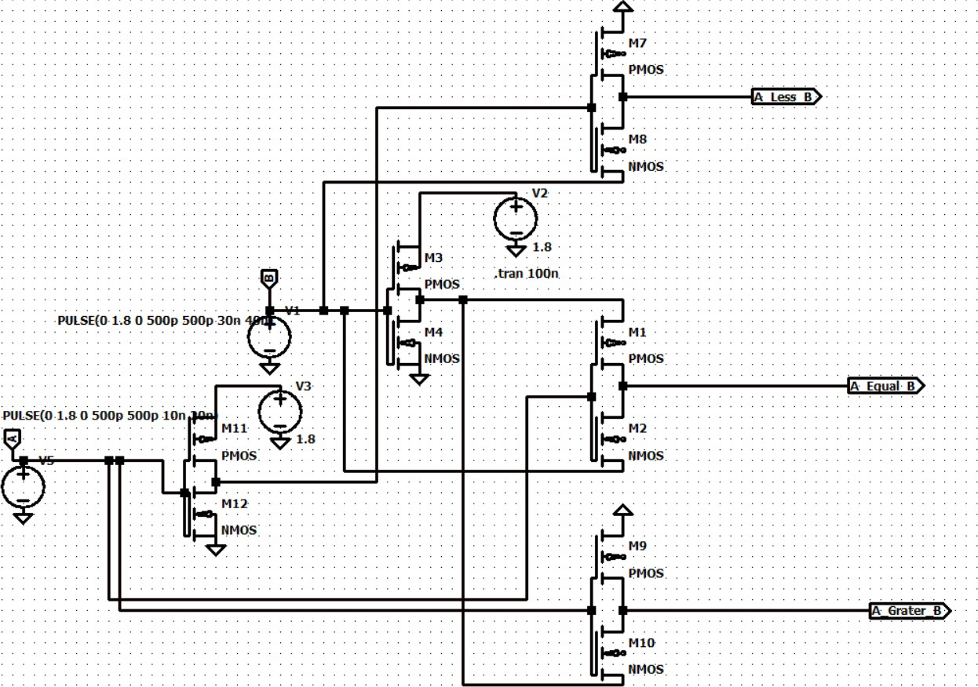

Figure 2: Transistor-level schematic of the proposed 10-transistor GDI-based 1-bit magnitude comparator implemented in LTSpice. The circuit generates all three outputs (A > B, A = B, A < B) using five GDI/inverter cells.

Table 4: Functional verification results across all comparator topologies.
A | B | Expected | Static CMOS | TGL | PTL | GDI
0 | 0 | A = B High | ✓ | ✓ | ✓ | ✓
0 | 1 | A < B High | ✓ | ✓ | ✓ | ✓
1 | 0 | A > B High | ✓ | ✓ | ✓ | ✓
1 | 1 | A = B High | ✓ | ✓ | ✓ | ✓

  - Performance of the proposed GDI comparator

Table 5 presents the measured timing, power, and energy parameters for each output of the proposed 10-transistor GDI comparator. The circuit exhibits balanced switching charac-teristics with propagation delays of 336 ps (A = B), 345 ps (A > B), and 353.50 ps (A < B). The average power dissipation is 34.18 pW, yielding a best-case PDP of 1.14 × 10⁻⁵ fJ.
The measured rise times (515–553 ps) are consistently larger than fall times (154–158 ps), reflecting the lower hole mobil-ity in PMOS transistors responsible for pull-up transitions. The rise-to-fall time ratio of approximately 3.3:1 is consistent with
the mobility ratio µ_{n}/µ_{p} ≈ 2.5 and confirms that the chosen PMOS sizing (W_{p}/W_{n} = 2) provides reasonable switching char-acteristics.
Table 5: Measured performance of proposed 10-transistor GDI comparator (180 nm PTM, V_{DD} = 1.8 V).
Performance Metric | A < B | A = B | A > B
Transistor count | 10
Rise time t_{r} (10%–90%) | 553.03 ps | 515.36 ps | 532.37 ps
Fall time t _{f} (90%–10%) | 154.21 ps | 157.73 ps | 158.19 ps
Propagation delay t_{pd} | 353.50 ps | 336.00 ps | 345.00 ps
Average power P_{avg} | 34.18 pW
Power-Delay Product (PDP) | 1.20 × 10⁻⁵ fJ | 1.14 × 10−5 fJ | 1.17 × 10⁻⁵ fJ

  - Benchmark comparator performance

Table 6 presents the measured parameters for all three bench-mark comparator topologies alongside the proposed GDI de-sign. The static CMOS comparator dissipates 130.61 pW with
32 transistors. The TGL comparator exhibits significantly higher average power (105.21 µW) due to crowbar current flowing through the complementary transmission gate switches during signal transitions. The PTL design matches the 10-transistor count of the GDI circuit with 38.12 pW power con-sumption but shows higher propagation delay (421.77 ps) due to threshold voltage drop and body-effect degradation.

Table 6: Performance summary and comparative evaluation of benchmark comparator topologies (180 nm PTM, 1.8 V, A = B output).
Metric | Static CMOS | TGL | PTL | Proposed GDI
Transistor count | 32 | 16 | 10 | 10
Device count reduction | Baseline | 50.00% | 68.75% | 68.75%
Average power P_{avg} | 130.61 pW | 105.21 µW | 38.12 pW | 34.18 pW
Power savings vs. CMOS | Baseline | — | 70.81% | 73.83%
Delay t_{pd} (A = B) | 398.09 ps | 587.24 ps | 421.77 ps | 336.00 ps
Speed improvement vs. CMOS | Baseline | −47.51% | −5.95% | +15.59%
PDP (A = B) | 5.10 × 10⁻⁵ fJ | 61.78 fJ | 1.60 × 10⁻⁵ fJ | 1.14 × 10−5 fJ
PDP improvement vs. CMOS | Baseline | — | 68.63% | 77.65%
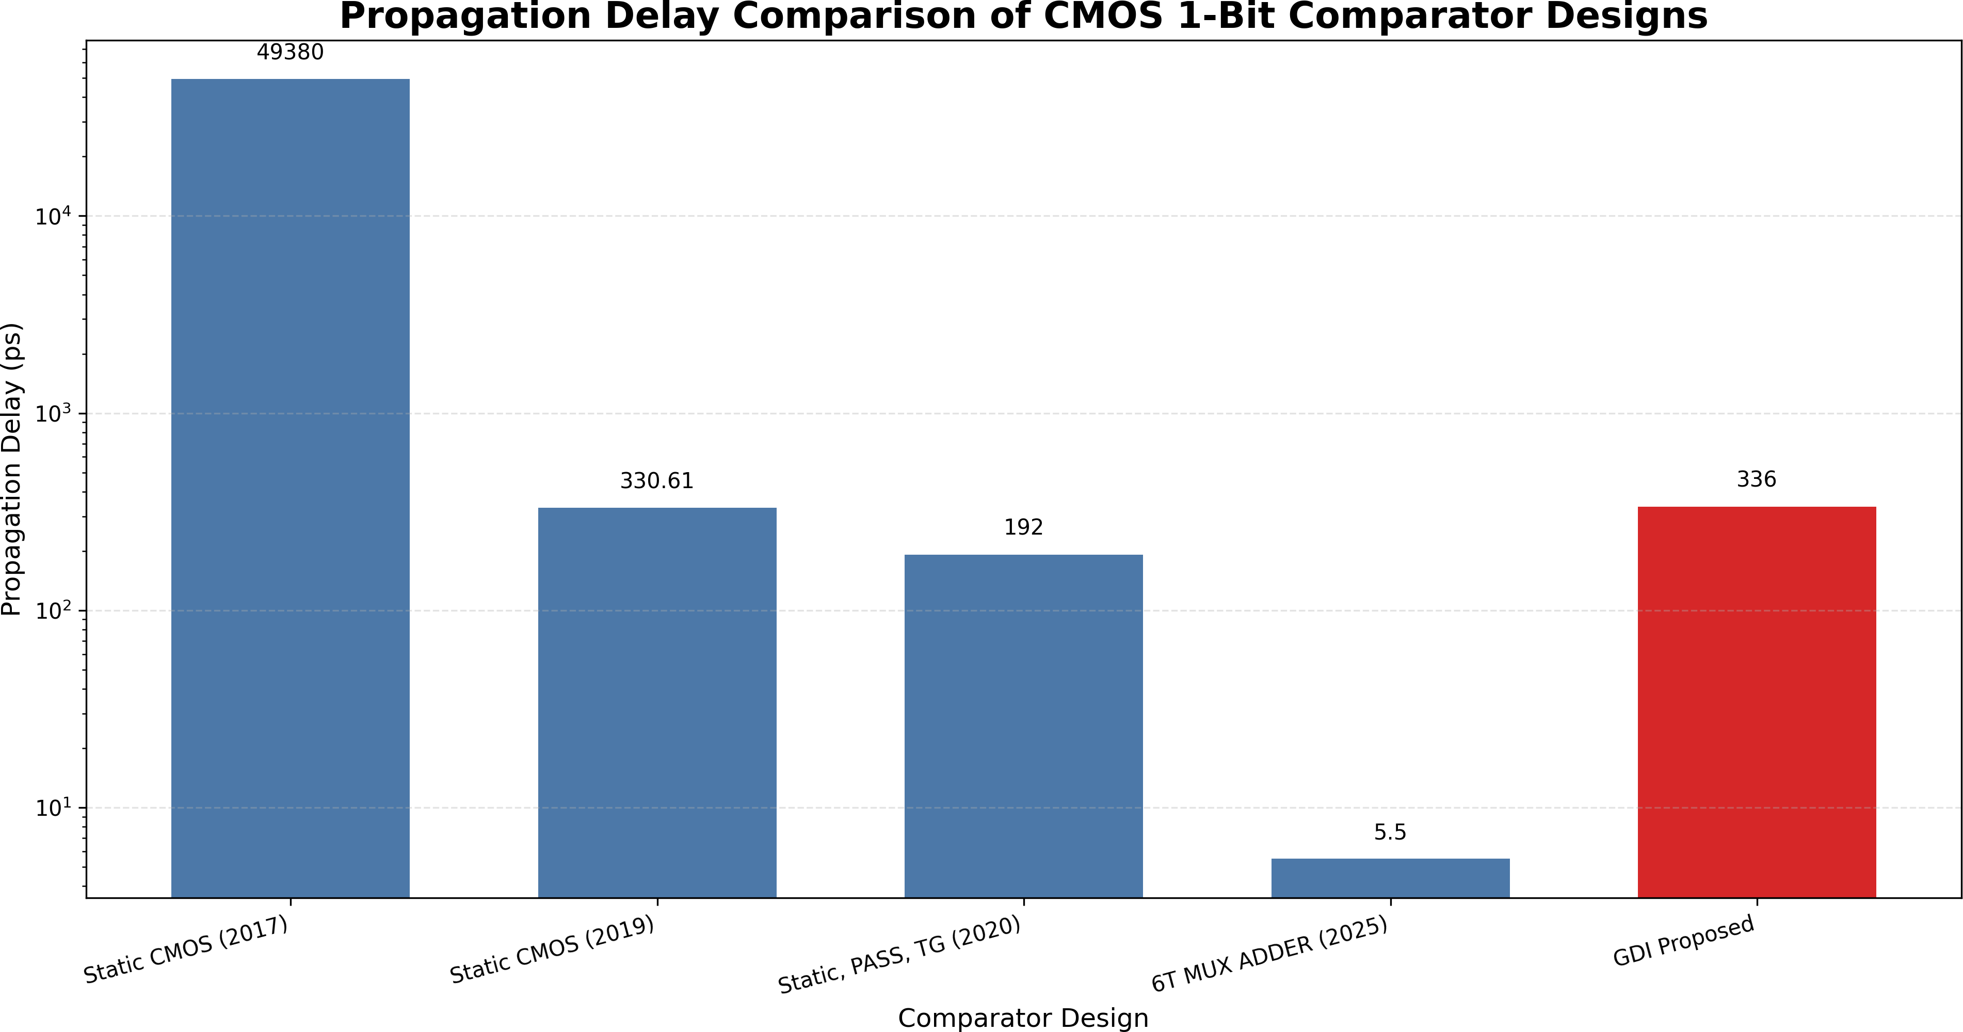
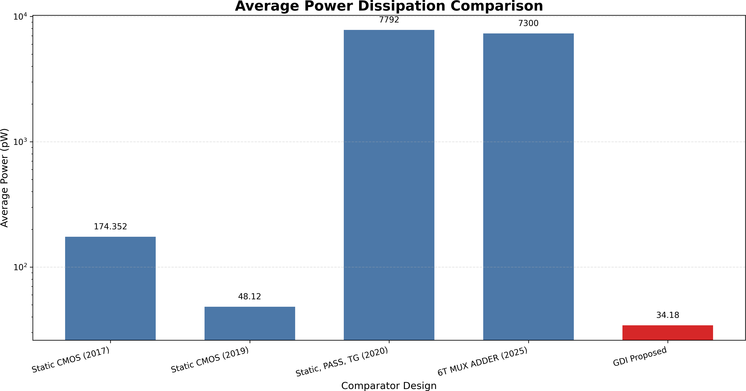

Figure 3: Propagation delay comparison of CMOS 1-bit comparator designs (logarithmic scale). The proposed GDI design achieves 336 ps, outperform-ing static CMOS (2017) and achieving comparable performance to MTCMOS (2019).

  - Comparative analysis with published literature
Table 7 compares the proposed GDI comparator against four published comparator architectures, organized in reverse chronological order from 2025 to 2017. The proposed de-sign achieves the lowest Power-Delay Product (1.14 × 10⁻⁵ fJ) among all evaluated designs.
Fig. 3, Fig. 4, and Fig. 5 present bar chart visualizations of the propagation delay, average power dissipation, and Power-Delay Product comparisons across all evaluated designs, re-spectively.

  - Technology node scaling evaluation
To assess scalability, simulations were extended across three PTM technology nodes: 180 nm (V_{DD} = 1.8 V), 90 nm (V_{DD} = 1.2 V), and 45 nm (V_{DD} = 1.0 V). Table 8 reports the propaga-tion delay for the A = B output at each node.

Discussion
  - Power dissipation analysis
The superior power performance of the proposed GDI com-parator stems from several interrelated factors. First, the re-duced transistor count (10 versus 32 in static CMOS) directly minimizes the total gate, drain, and interconnect capacitance,
Figure 4: Average power dissipation comparison (logarithmic scale). The pro-posed GDI comparator achieves the lowest power consumption (34.18 pW), representing a 73.83% reduction over conventional static CMOS.

lowering dynamic switching power. Second, the GDI design has fewer internal switching nodes compared to conventional implementations, reducing the total capacitance that must be charged and discharged during each logic transition. Third, GDI cells route input signals directly through transistor diffu-sion terminals, avoiding the need for separate buffering stages that would consume additional power. Fourth, the complemen-tary structure of each GDI cell (one PMOS, one NMOS) limits the simultaneous conduction window during input transitions, reducing short-circuit power dissipation.
The 73.83% power reduction compared to static CMOS (34.18 pW versus 130.61 pW) is particularly noteworthy be-cause it is achieved without recourse to specialized fabrica-tion techniques such as multi-threshold voltage implants, which are required by MTCMOS approaches like that of Tailor et al. [3]. The proposed design operates within standard single-V_{th} CMOS process specifications, reducing manufacturing com-plexity and cost.

  - Propagation delay analysis
The GDI comparator achieves the lowest propagation delay (336 ps) among all four modeled topologies due to several ar-chitectural advantages. The direct signal path through a sin-gle transistor (either PMOS or NMOS) in each GDI cell mini-mizes the RC delay along the critical path. Unlike PTL, where

Table 7: Performance comparison with published comparator implementations arranged in reverse chronological order.
Reference | Design Architecture | Delay (t_{pd}) | Power (P_{avg}) | PDP (fJ)
Sharma et al. (2025) [1] | PTL-GDI-TGL hybrid | 5.5 ps | 7.3 µW | 0.04
Lubaba et al. (2020) [2] | PTL-TG-CMOS hybrid (2-bit) | 0.192 ns | 7.792 µW | 1.496
Tailor et al. (2019) [3] | MTCMOS with forced stack | 330.61 ps | 48.12 pW | 1.59 × 10⁻⁵
Kumar & Kumar (2017) [4] | CMOS with stacking | 49.38 ns | 174.35 pW | 0.0086
Proposed GDI (This work) | Pure GDI 10-transistor | 336 ps | 34.18 pW | 1.14 × 10−5

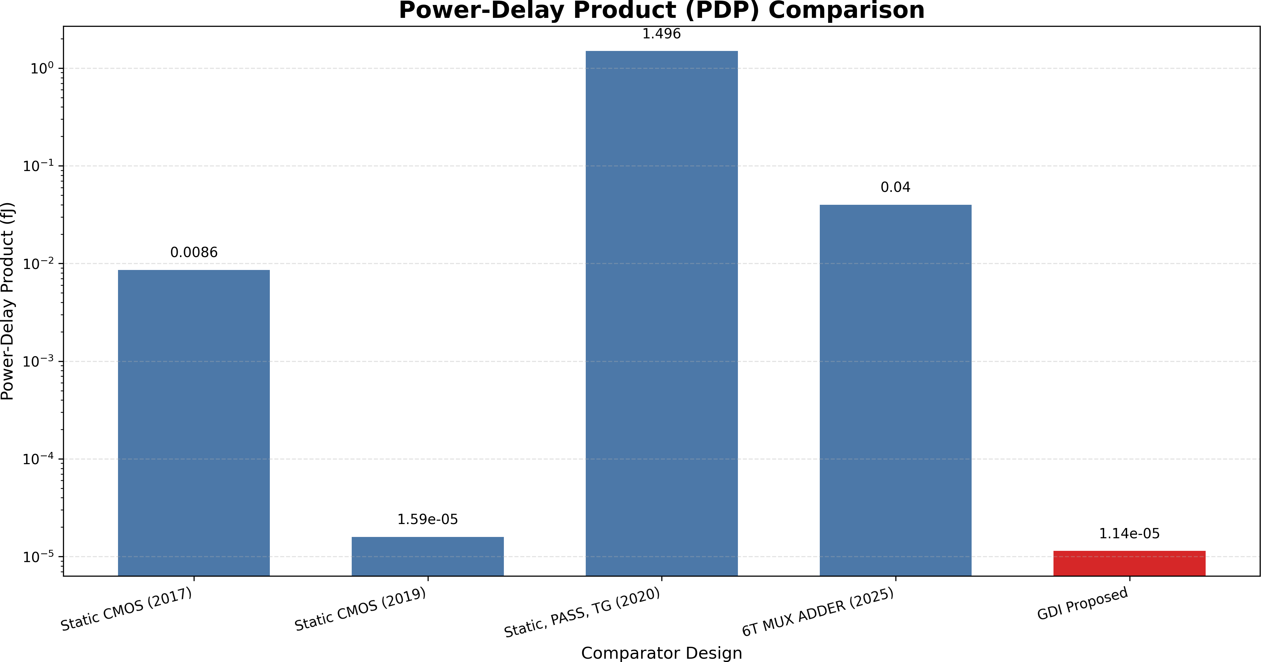

Figure 5: Power-Delay Product comparison (logarithmic scale). The proposed GDI comparator achieves the lowest PDP (1.14 × 10⁻⁵ fJ), confirming superior energy efficiency over all benchmark topologies.

Table 8: Propagation delay (t_{pd}) for the A = B output across PTM technology nodes.
Technology Node | Static CMOS | TG Logic | PTL | Proposed GDI
180 nm PTM | 35.54 ns | 25.54 ns | 25.21 ns | 25.50 ns
90 nm PTM | 35.19 ns | 35.91 ns | 25.21 ns | 25.50 ns
45 nm PTM | 35.54 ns | 25.62 ns | 25.25 ns | 25.35 ns

NMOS pass transistors exhibit a threshold voltage drop when transmitting logic-high signals, the GDI cell configuration en-sures that both logic-high and logic-low levels are transmitted without significant voltage degradation, enabling faster switch-ing in downstream logic. Additionally, each GDI output cell has a fan-in of only 2, keeping input capacitance low and re-ducing the delay associated with charging and discharging gate capacitances.
  - Detailed literature comparison
Versus Sharma et al. [1]: While the Sharma design achieves a shorter delay (5.5 ps versus 336 ps), the proposed GDI com-
parator attains approximately 2.14×10⁵ times lower power con-sumption (34.18 pW versus 7.3 µW) and 3,509× lower PDP, demonstrating vastly superior energy efficiency. The Sharma
design also requires 24 transistors compared to only 10 in the proposed design.
Versus Lubaba et al. [2]: The proposed design operates at approximately 2.28 × 10⁵ times lower power (34.18 pW versus 7.792 µW) and achieves a 1.31 × 10⁸ times lower PDP. It should be noted that the Lubaba design is a 2-bit comparator, making
direct comparison complex; however, the orders-of-magnitude
power difference underscores the efficiency advantage of the pure GDI approach.
Versus Tailor et al. [3]: The proposed design achieves comparable delay performance (336 ps versus 330.61 ps, only 1.6% slower) while delivering 28.97% lower power consump-tion (34.18 pW versus 48.12 pW) and 28.3% lower PDP. Cru-cially, the GDI approach eliminates the need for dual-threshold fabrication, reducing manufacturing cost and complexity.
Versus Kumar & Kumar [4]: The proposed GDI design achieves a 147× speed improvement (336 ps versus 49.38 ns) and an 80.39% power reduction (34.18 pW versus 174.35 pW). The PDP improvement is approximately 754× (1.14 × 10⁻⁵ fJ versus 0.0086 fJ). This dramatic improvement is attributed to
the elimination of stacking-related series resistance and the re-duced parasitic capacitance of the 10-transistor topology.
  - Scaling behavior
The multi-node evaluation reveals that the proposed GDI comparator maintains remarkably stable delay performance across all three technology nodes, with less than 1% variation (25.50 ns at 180 nm, 25.50 ns at 90 nm, and 25.35 ns at 45 nm). This stability confirms that the GDI architecture scales pre-dictably with decreasing gate lengths and is well-suited for im-plementation in advanced technology nodes. The PTL design also shows stable performance, while the TGL design exhibits an anomalous delay increase at 90 nm (35.91 ns versus 25.54 ns at 180 nm), which may be attributed to increased sensitivity of transmission gate on-resistance to threshold voltage variations at lower supply voltages.
  - Limitations and future perspectives
The findings of this study should be interpreted considering certain methodological limitations. First, simulations were con-ducted at the schematic level using lumped PTM device mod-els; physical layout parasitic extraction and 3D interconnect ef-fects were not included. Second, process–voltage–temperature (PVT) corner analysis and Monte Carlo mismatch evaluations were not performed, which would provide additional insight into statistical robustness. Third, fan-out loading effects from subsequent logic stages were not modeled, which would in-crease output capacitance and affect delay measurements. Fu-ture research should extend the 1-bit GDI comparator to multi-bit (4-bit, 8-bit) hierarchical architectures, perform full custom physical layout with post-layout parasitic extraction, and eval-uate the design in emerging technologies such as FinFET and Gate-All-Around nanosheets.

Conclusion

This paper has presented the design, implementation, and multi-parameter performance evaluation of an ultra-low-power 10-transistor 1-bit magnitude comparator based on the Gate Diffusion Input technique. The circuit was modeled and simu-lated in LTSpice using the 180 nm Berkeley Predictive Technol-ogy Model with a 1.8 V supply voltage. The principal findings are summarized as follows:
- The proposed GDI comparator generates all three com-parison outputs (A > B, A = B, A < B) using only 10 transistors, achieving a 68.75% reduction in device count compared to the 32-transistor conventional static CMOS implementation.
- The circuit achieves an average power dissipation of
34.18 pW, representing a 73.83% reduction relative to the static CMOS baseline (130.61 pW) and a 10.34% reduc-tion relative to Pass Transistor Logic (38.12 pW).
- For the equality output (A = B), the propagation delay of 336 ps outperforms static CMOS (398.09 ps), Trans-mission Gate Logic (587.24 ps), and Pass Transistor Logic (421.77 ps) by 15.59%, 42.78%, and 20.33%, respectively.
- The Power-Delay Product of 1.14 × 10⁻⁵ fJ confirms that the proposed design achieves the highest energy efficiency among all evaluated topologies, including four published
comparator architectures from the literature.
- Multi-node technology scaling evaluations across 180 nm, 90 nm, and 45 nm demonstrate consistent performance scalability with less than 1% delay variation across nodes.
These results establish the proposed GDI-based compara-tor as a compelling candidate for deployment in energy-constrained VLSI applications, including battery-operated portable electronics, wireless sensor networks, implantable biomedical devices, and edge computing architectures.

Declaration of competing interest

The authors declare that they have no known competing fi-nancial interests or personal relationships that could have ap-peared to influence the work reported in this paper.

Data availability

All simulation data and circuit netlists used in this study are available from the corresponding author upon reasonable re-quest.

Acknowledgments

The authors express their gratitude to the Department of Electrical and Electronic Engineering, International Islamic University Chittagong, for providing the computational re-sources and academic support necessary for this research.

References
- Y. Sharma, B.S. Premananda, D. Raj, K. Pandey, Design and analysis of a 1-bit comparator for low power VLSI systems, in: Proc. 2025 Third Int. Conf. Networks, Multi-media Inf. Technol. (NMITCON), Bengaluru, India, 2025,
pp. 1–6.
- S. Lubaba, M.S. Islam, K.M. Faisal, M. Hasan, Design of a two-bit magnitude comparator based on pass transistor, transmission gate and conventional static CMOS logic, in: Proc. 2020 IEEE Region 10 Symp. (TENSYMP), Dhaka, Bangladesh, 2020, pp. 1114–1117.
- D. Tailor, T. Sharma, M. Kumar, Design of CMOS based 1-bit comparator with MTCMOS and forced stack tech-nique in 180 µm technology, in: Proc. 2019 IEEE Int. Conf. Signal Process. Commun. (ICSC), NOIDA, India, 2019, pp. 330–334.
- A. Kumar, M. Kumar, Improved design of CMOS 1-bit comparator with stacking technique, Int. J. Curr. Eng. Technol. 7 (3) (2017) 1044–1047.
- A. Morgenshtein, V. Yuzhaninov, A. Kovshilovsky,
A. Fish, Full-swing gate diffusion input logic—case-study of low-power CLA adder design, Integration, VLSI J. 47 (1) (2014) 62–70.
- International Technology Roadmap for Semiconductors (ITRS), Process integration, devices, and structures, Semiconductor Industry Association, 2013.
- N.H.E. Weste, D.M. Harris, CMOS VLSI Design: A Cir-cuits and Systems Perspective, fourth ed., Pearson Educa-tion, Boston, MA, 2011.
- M. Alioto, E. Consoli, G. Palumbo, General strategies to design nanometer flip-flops in the energy-delay space, IEEE Trans. Circuits Syst. I, Reg. Papers 57 (7) (2010) 1583–1596.
- R.J. Baker, CMOS: Circuit Design, Layout, and Simula-tion, third ed., Wiley-IEEE Press, Hoboken, NJ, 2010.
- W. Zhao, Y. Cao, Predictive technology model for nano-CMOS design exploration, ACM J. Emerg. Technol. Comput. Syst. 3 (1) (2007) 1–17.
- B.S. Deepaksubramanyan, A. Nunez, Analysis of sub-threshold leakage reduction in CMOS digital circuits, in: Proc. 50th Midwest Symp. Circuits Syst. (MWSCAS), Montreal, Canada, 2007, pp. 1400–1404.
- S. Narendra, A. Chandrakasan, Leakage in Nanometer CMOS Technologies, Springer, New York, NY, 2006.
- S. Kang, Y. Leblebici, CMOS Digital Integrated Circuits: Analysis and Design, third ed., McGraw-Hill, New York, NY, 2003.

- J.M. Rabaey, A. Chandrakasan, B. Nikolic, Digital Inte-grated Circuits: A Design Perspective, second ed., Pren-tice Hall, Upper Saddle River, NJ, 2003.
- K. Roy, S. Mukhopadhyay, H. Mahmoodi-Meimand, Leakage current mechanisms and leakage reduction tech-niques in deep-submicrometer CMOS circuits, Proc. IEEE 91 (2) (2003) 305–327.
- A. Morgenshtein, A. Fish, I.A. Wagner, Gate-diffusion input (GDI): a power-efficient method for digital com-binational circuits, IEEE Trans. Very Large Scale Integr. (VLSI) Syst. 10 (5) (2002) 566–581.

